Andy Chia – 101111058

COMP3005 Project

2.1

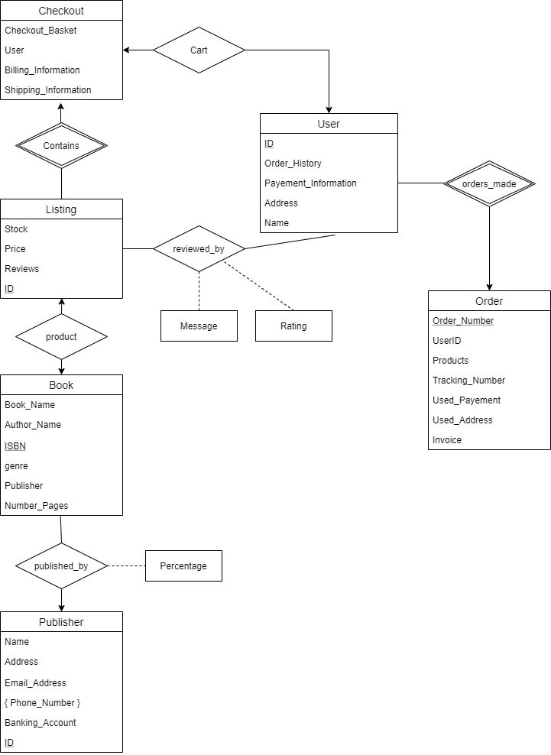

2.2

Tables:

Checkout(Checkout_Basket, User_ID, Billing_Information, Shipping_Information)

User(ID, Order_History, Payement_Information, Address, Name)

Order(Order_number, Products, Tracking_Number, Used_Payement, Used_Address, Invoice)

Listing(ID, Stock, Price, ISBN)

Book(ISBN, Book_Name, Author_Name, genre, Publisher, Number_Pages)

Publisher(ID, Name, Address, Email_Address, Phone_Number, Banking_Account)

Relation Sets

orders_made(User_ID, Order_Number)

Contains(Checkout_Basket, Listing_ID)

reviewed_by(User_ID, Product_ID, Message, Rating)

published_by(ISBN, Publisher_ID, Percentage)

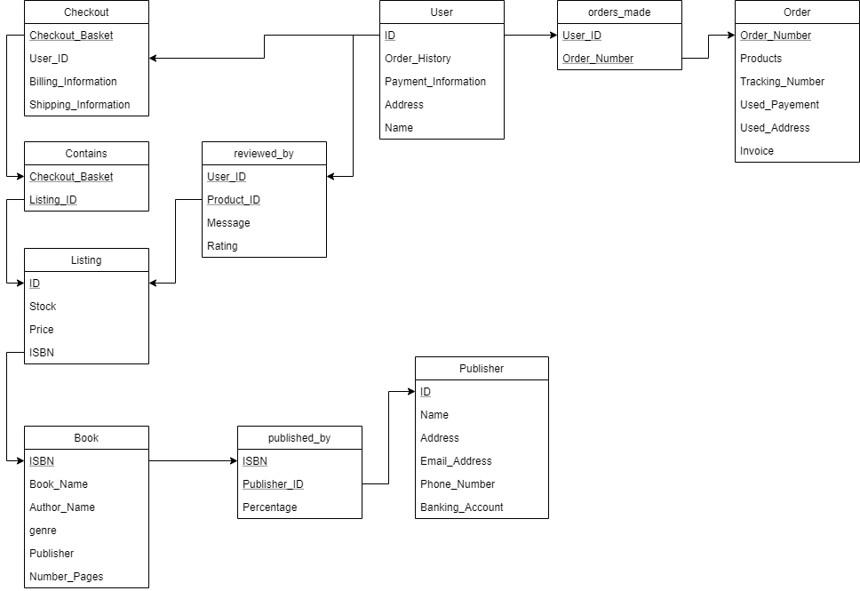

2.3

Functional Dependencies

f = {

User_ID -> Order_History, Payement_Information, Address, Name (**User**)

Payement_Information -> Address, Name (**User**)

Checkout_Basket -> User_ID (**Checkout**)

Checkout_Basket, User_ID -> Billing_Information, Shipping_Information (**Checkout**)

Order_Number -> Tracking_Number, Products, Invoice, Used_Payement (**Order**)

Tracking_Number -> Used-Address (**Order**)

User_ID -> Product_ID (**reviewed_by**)

User_ID, Product_ID -> Message (**reviewed_by**)

User_ID, Product_ID -> Rating (**reviewed_by**)

ID -> Stock, Price, ISBN (**Listing**)

ISBN -> Author_Name, Publisher (**Book**)

Author_Name -> Book_Name (**Book**)

ISBN, Author_Name, Publisher -> genre, Number_Pages, Book_Name (**Book**)

ISBN, Publisher_ID -> Percentage (**published_by**)

ISBN -> Publisher_ID (**published_by**)

ID -> Name, Address, Email_Address, Phone_Number, Banking Account

}